**Executive Summary**

**Our mixed methods study will examine police shootings as a fundamental cog linking historical racism and contemporary health outcomes and racial disparities in health.**

**Police shootings are a significant societal and public health problem.** In 2023, 558 people have been fatally shot by police.1 One of the fundamental causes of police shootings is the structural racism embedded in the history and contemporary operation of policing and other social institutions. America’s history of racial violence and slave patrols is reflected in police shootings of Black people today.2 A Black unarmed person is shot by police about 3.5 times more than a white unarmed person.3(pp2011–2014) Both direct and indirect exposure to police violence increases individuals’ reports of general anxiety, depression, trauma symptoms, suicide attempts, and anticipation of future police violence victimization.4–6 Further, the health effects of police violence extend beyond individual injury to influence population health outcomes.7,8

**Historical structural racism is linked to contemporary health outcomes, however knowledge on the mechanisms are limited.**9Health researchers have begun to operationalize historical forces of structural racism through the mid-20th century practice of “redlining”, wherein neighborhoods were graded by the Home Owners’ Loan Corporation (HOLC). The criteria for these grades, ranging from “A” to “D”, were highly racialized, effectively and intentionally conflating “race” with “financial risk.”10 People or communities living in areas with lower HOLC grades have experienced worse contemporary outcomes, specifically mental health4 and racial disparities in life expectancy11 among other outcomes. Scholarship has begun to identify the mediating mechanisms of the processes by which historical racialization translates into contemporary health realities.12 However, existing research has only begun to conceptualize contemporary racialized criminal legal practices as a fundamental mechanism in this historical process. One recent study examined historical redlining in 192 cities and found fatal police encounters were more likely to occur in census tracts in formerly redlined areas.13.

**The perceived threat of police violence is a prominent feature of being a minoritized person in the United States.**14 However, Black and other minoritized communities have learned to navigate these systems of historic and present day oppression. Research suggests that ethnic-racial socialization,a common feature of Black and other minoritized populations, may weaken the impact of discrimination.15 Further, how a neighborhood is policed may impact one's residential preferences.16 However, there is limited research studying the impact of police shootings on population health by identifying potential mechanisms, such as resiliency, that shape the health consequences of police shooting exposure.

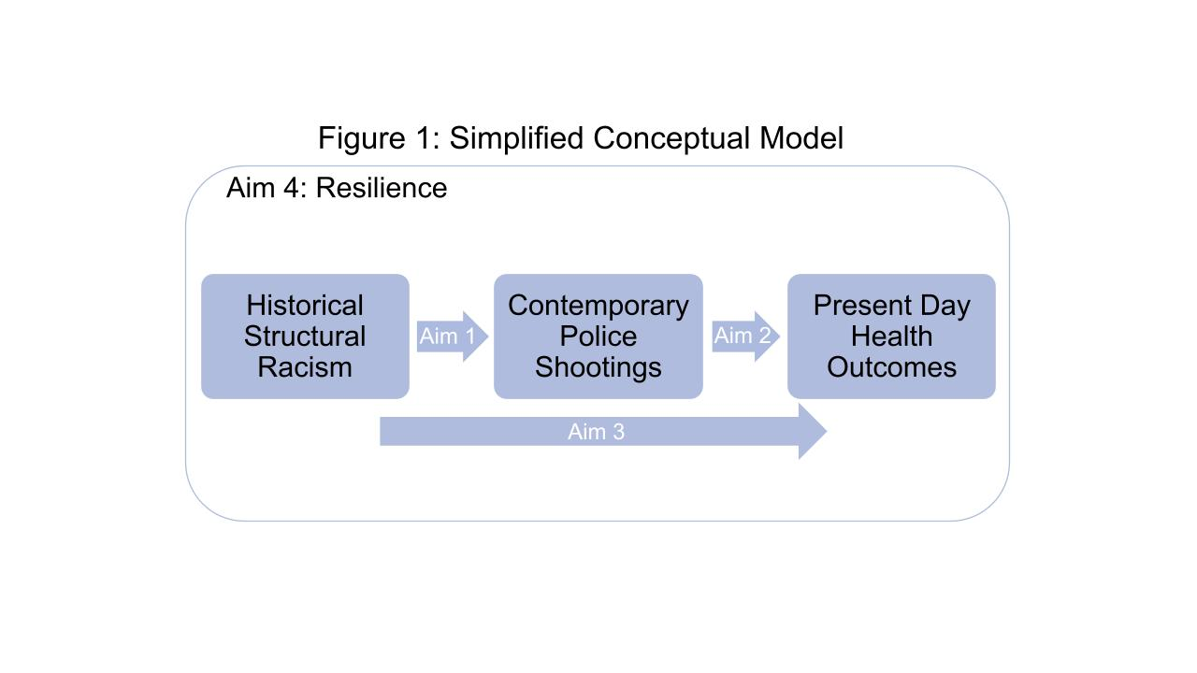

**Racially discriminatory policing, and particularly police shooting, is white supremacy in action.**17In Figure 1 (left), we conceptualize police shootings, as an instance of the institutionalization of structural racism that links historical structural racism to contemporary health outcomes and disparities. In concert with previous research, we conceptualize the health impacts of police shootings to not only include those directly subject to extreme forms of use of force, but also the broader public health impacts on those exposed to police violence as well as entire communities.

We leverage a mixed method design in the “Twin Cities” of Minneapolis and St. Paul, Minnesota. The Twin Cities are selected on the basis of the unique and detailed historical and contemporary administrative data that can be spatially situated in each municipality, as well as the urgent need for research and policy guidance following the U.S. Justice Department’s finding of unlawful discrimination and excessive force in the Minneapolis Police Department.18 Our study will combine data from the Minnesota Hospital Association,19 Minneapolis and St. Paul policing records,20,21 Decennial Census22 and American Community Survey (ACS),23 racial covenant,24 and HOLC data25 from 1930 to 2023 to address the following aims:

**AIM 1. Examine how historical redlining and racial covenants26 impact police shootings.**

We will model the relationship between HOLC grades and racial covenants and police shootings using spatial lag autocorrelation models, statistically adjusting for the spatial autocorrelation of police shootings between neighboring ZIP Code Tabulation Areas (ZCTA) and pre-exposure variables from the 1930 Census. We will also estimate models with and without contemporary controls such as: demographics, concentrated disadvantage, and homicide.

**AIM 2.** **Examine the impact of police shootings on health (eg firearm assault injury, mental health, substance use, and suicide).**

We model the relationship between police shootings and health using two-way fixed-effect panel models for each health outcome, which controls for time-constant heterogeneity between ZCTAs, and ZCTA-constant heterogeneity between years. We will include time-varying controls including the homicide rate, demographic and economic changes, and other measures of police behavior (e.g., stops, other uses of force).

**AIM 3. Examine to what extent police shootings mediate the relationship between historical redlining and racial covenants and health.**

We perform a counterfactual mediation analysis27 to quantitatively assess the extent to which police shootings mediate the relationship between historical structural racism and contemporary health outcomes. This approach appropriately models mediation relationships when the focal treatment variable (e.g., racial covenants) impact confounders of the mediator-outcome relationship, violating the “cross-world independence” assumption (see details below).

**AIM 4. Understand how police shootings affect health outcomes, and how strategies of resilience used by community members may shape these processes.**

First, we will conduct 3 focus group interviews with 18 residents of impacted ZCTAs within Minneapolis and St. Paul (i.e., 3 focus groups of six participants each), prioritizing residents in areas of historic redlining. We will use these focus groups to obtain residents’ feedback on proposed interview questions, identify additional areas of inquiry, and discuss potential policy solutions. Then we will conduct 40 individual semi-structured interviews to understand how police shootings affect health outcomes, and how strategies of resilience used by community members may shape these processes.

**Equity.** The ultimate goal of our project is to center the voices of the traditionally marginalized and powerless. We adopt an asset-based, trauma-informed approach to minimize potential harm to participants and to highlight the existing strengths of traditionally marginalized communities. Our project will make three equity-focused contributions. First, we hope to elucidate the mechanism by which health disparities occur in our society, and to better understand the historical roots of these inequities. Second, the interviews we conduct in communities where police shootings occurred will help inform future interventions that build upon existing resilience in minoritized communities. Third, the analytical framework we will establish will allow for additional examinations of different health conditions.

**Research Team.** Our interdisciplinary research team has worked together for 4 years. We are well-positioned for this research, having produced several manuscripts on police violence,28,29 firearm assault injury,28 and related phenomena.30

**Dissemination.** We will prepare peer reviewed articles, research briefs, conference presentations and press releases. In addition, all of our manuscripts, reports, analytic code, and non-identifying data (when ethically allowable) will be made publicly available.

**Project Narrative**

**Research Questions**

The goal of our mixed-method project is to advance knowledge on the complex interplay[1](https://www.zotero.org/google-docs/?broken=KMGyeD) of historical/contemporary racism, police shootings, and health. We propose to:

AIM 1. Examine how historical redlining and racial covenants26 impact police shootings.

AIM 2. Examine the impact of police shootings on health.

AIM 3. Examine to what extent police shootings mediate the relationship between historical redlining and racial covenants and health.

AIM 4. Understand how police shootings affect health outcomes, and how strategies of resilience used by community members may shape these processes.

**Significance**

**Since the beginning of 2023, 558 people have been fatally shot by police.**1This averages out to approximately 2 deaths by police using firearms per day with many more non-fatal shootings likely going untallied. Our proposed project will link local historical indicators of structural racism to contemporary police shootings and health outcomes. One of the fundamental causes of police shootings is the structural racism embedded in the history and contemporary operation of policing and other social institutions. Structural racism, in terms of health outcomes, is “the state-sanctioned or extralegal production and exploitation of group-differentiated vulnerability to premature death.”1 Racialized violence has been pervasive throughout United States history. America’s history of racial violence and slave patrols is reflected in the police shootings against Black people today.2 A Black unarmed person is shot by police about 3.49 times more than a white unarmed person. Over the life course, Black men face about a 1 in 1,000 chance of being killed by police, a risk that is 2.5 times more likely as compared to white men. A large proportion of police shootings are targeted against Black people, however, individuals with other marginalized identities (e.g., other racial/ethnic groups, sex workers, or transgender people) are impacted disproportionally as well.7 Both direct and indirect exposure to police violence increase individuals’ reports of general anxiety, depression, trauma symptoms, suicide attempts, and anticipation of future police violence victimization.4–6

**Historical structural racism is linked to contemporary health outcomes.** Historical forces of structural racism can be difficult to measure, but the mid-20th century practice of “redlining” provides an important operational indicator. In redlining, neighborhoods were graded by the Home Owners’ Loan Corporation (HOLC), which dictated each space’s suitability for financial investment. The criteria for these grades, ranging from “A” to “D”, were highly racialized2 , intentionally and effectively conflating “race” with “financial risk” and defining, in part, a space’s current and future value as a function of its racial composition. Scholars have tied HOLC grades to contemporary health outcomes, such as self-rated health3, mental health4, racial disparities in life expectancy5, cancer diagnoses6 and non-fatal gun injuries7. Scholarship has begun to identify the mediating mechanisms (e.g., urban renewal funding, crime, home values, school segregation) by which historical structural racism translates into contemporary health realities.56 However, existing research has not conceptualized contemporary criminal legal practices as a fundamental mechanism in this historical process. In particular, we theorize that *police shootings are a fundamental mechanism* by which historical racism structures contemporary health outcomes and the racial disparities within them (Figure 1 above).

**The perceived threat of police violence is a prominent feature of being a minoritized person in the United States**.14 However, despite this central feature, Black and other minoritized communities have learned to navigate these systems of historic and present day oppression. Current research suggests that ethnic-racial socialization,a common feature of Black and other minoritized populations, may weaken the impact of discrimination.15 Further, how a neighborhood is policed may impact one's residential preferences.16 However, there is limited research studying the impact of police shootings on population health by identifying potential mechanisms, such as resiliency, that shape the health consequences of police shooting exposure.

**There are preliminary examinations of the historical causes of police shootings, however limited.** A recent study examined historical redlining in 192 cities and found fatal police encounters were more likely to occur in census tracts in formerly redlined areas.

In this study we engage the work on both historical structural racism roots of health, combined with the literature on the racialized causes and consequences of police violence, and ask to what extent police shootings mediate the relationship between historical structural racism and contemporary health indicators. We engage and extend these literatures by a) estimating the impact of historical structures of racism on contemporary rates of police shootings, b) estimating the effect of police shootings on firearm assault injury and other health outcomes, and c) assessing the extent to which police firearm violence mediates the relationship between historical racism and contemporary health. By doing so, we hope to advance not only our understanding of the causes of police violence and firearm use, but also seek to better understand what role police firearm violence plays in historical processes of structural racism and the (re)production of firearm injury and other contemporary health problems. Our study will help to quantify the health impacts of police shooting above and beyond a single focal event.

**Innovation**

The project incorporates 3 key innovations:

**1.Fine-grained spatial and temporal data.** We leverage fine-grained spatiotemporal data on historical racial exclusionary processes, police shootings, and health outcomes at the ZCTA-level. Further, much police shooting data relies on only fatal encounters with police reported in the aggregate, and the existence of spatially-locatable individual police shooting incidents allows for the fine-grained measurement of police shooting incidents by place and time. Finally, our use of hospital discharge data allows us to spatially-locate health outcomes such as mental health diagnoses by patient residence.

**2.Incorporation of focus groups and interviews**. Focus groups and interviews will help to understand and contextualize the role of coping strategies and resiliency in shaping the health effects of exposures to police shootings. Despite the burgeoning quantitative literature on policing and population health, we know little about the specific individual-level mechanisms that connect police violence and adverse health outcomes, as well as what individual-level factors may attenuate these linkages.

**3.Counterfactual mediation framework.** Our counterfactual mediation framework allows for the estimation of direct and indirect effects of structural racism allowing for the downstream mediators and covariates to reflect their relationships to the exposure level of redlining and racial covenants. This methodology circumvents indefensible assumptions when studying historical processes of racism.

**Methodological Approach**

*Study Design, Setting, and Population*

Our research methodology to investigate the impact of historical structural racism on contemporary police violence and health outcomes is a mixed method design in Minneapolis and St. Paul, Minnesota. Colloquially known as the “Twin Cities” this metropolitan area is chosen for the existence and availability of fine-grained spatial data on redlining and racial covenants, police shootings, and hospital discharge data. We spatially situate our quantitative data at the Zip Code Tabulation Area (ZCTA)-level, and therefore our target population is the population of ZCTAs within the city boundaries of Minneapolis and St. Paul, MN. In our qualitative design, our target population is residents of Minneapolis and St. Paul, MN ZCTAs that have experienced a police shooting since 2015. We propose a quantitative historical and administrative data analysis to assess Research Aims 1-3, and a qualitative interview design to assess Aim 4, each of which we discuss in turn.

*Quantitative Historical and Administrative Data Analysis (Aims 1-3)*

We first propose a quantitative historical and administrative data analysis of several secondary data sources in Minneapolis and St. Paul, Minnesota. To build the structure of our theorized historical process (see Figure 1), we will construct a unique longitudinal dataset situated at the Zip Code Tabulation Area (ZCTA) level drawing on data from the sources described below.

Data and Measures

Our key exposures are the spatial presences of redlining and racial covenants in each city. Historical spatial data on HOLC redlining grades are obtained from the Minnesota Natural Resource Atlas for both Minneapolis and St. Paul.25 These data consist of HOLC grades, ranging from “A” to “D”, alongside spatial shapefiles for each graded space. Shapefiles of racial covenants - clauses inserted in property deeds to prevent non-white individuals from owning or renting space - are obtained from the Mapping Prejudice Project at the University of Minnesota.24 We will then construct indicators of the proportion of each ZCTA polygon that *overlaps* with different HOLC graded spaces and racial covenants, effectively constructing proportional measures of each ZCTA polygon that was historically subject to these racialized exclusionary projects. For example, a ZCTA that had half of its area redlined would receive a score of .5 on our redlining measure. The ZCTA-level indicators of the proportions of grades and covenants represent key manifestations of historical structures of racialized violence that codified existing forms of racial discrimination into official, state-sponsored policy.

The distal outcomes of interest are rates of health outcomes in Minneapolis and St. Paul. We leverage administrative hospital claims data obtained through the Minnesota Hospital Association from 2022-2023.19 The hospital claims database includes inpatient and outpatient data for each patient encounter with a health care provider and includes the diagnosis of each event (International Classification of Diseases (ICD) codes). We spatially locate each discharge by ZCTA, the lowest level of geography available in the hospital claims data. We will then construct ZCTA-specific measures of rates of various health outcomes, including firearm assault injury, mental health, substance use, and suicide. Each outcome will be expressed as a rate per 1,000, and we will obtain population denominators from the 2020 Decennial Census. Further, we will also create racially stratified measures which will allow us to investigate effect heterogeneity with respect to racial subgroups in Minneapolis and St. Paul.

We will obtain administrative data on police officer involved shootings and crime as reported by the Minneapolis and St. Paul police departments.20,21 These data are publicly available via each municipality's open data portal. We will spatially locate each police shooting by ZCTA, and will create both dichotomous indicators of the presence of a police shooting in each ZCTA, as well as a rate per 1,000 residents using the 2018-2021 5-year American Community Survey Estimates. These measures represent our focal mediating variables of interest in our theoretical model (see Figure 1). Previous research has tied contemporary rates of violent crime to historical redlining patterns, as well as levels of police violence. We therefore use each municipality's open crime data to construct ZCTA-specific rates of homicide per 1,000 to control for this potentially confounding relationship.

Finally, we obtain spatial demographic data from the Decennial Census22 and American Community Survey (ACS)23 from the United States Census Bureau. These data serve as our key pre-exposure controls (1930 Census), as well as key control measures of contemporary demographics (2000-2006 Census/ACS) that may confound the relationship between police shootings and health. At each time point, we construct a bevy of racial, economic, educational, age, and gender demographics as well as several time-varying controls including the homicide rate, demographic and economic changes, changes in COVID-19 related state policy, and other measures of police behavior (e.g., stops, other uses of force). Given that spatial ZCTA boundaries change over time, we use population-weighted interpolation to intelligently transfer 1930 Census data to contemporary ZCTA boundaries.

Statistical Analysis

In Aim 1, we will model the relationship between our historical exposure measures of HOLC grades and racial covenants and police shootings using spatial lag autocorrelation models, statistically adjusting for the spatial autocorrelation of health outcomes between neighboring ZCTAs as well as a suite of pre-exposure variables from the 1930 Census. We will also estimate models with and without contemporary measures of demographics, concentrated disadvantage, and homicide to isolate the direct effect of structural racialized exclusion, and examine the indirect effects that operate via contemporary social structure.

In Aim 2, we model the relationship between police shootings and crime using two-way fixed-effect panel models for each health outcome, which control for time-constant heterogeneity between ZCTAs, and ZCTA-constant heterogeneity between years. Because we have a longer series of temporal data in the contemporary period (2008-2023), this allows for the use of a panel dataset comprising each ZCTA from 2008-2021. This two-way fixed effects model effectively models within-unit time variation that is not shared across all years, and the causal identification of our estimated police shooting effect (presence or the rate) on each health outcome relies upon the assumption that the remaining time variance is independent of unobserved time-varying heterogeneity.

In Aim 3, we use a counterfactual mediation approach27 to assess the extent to which police shootings mediate the relationship between historical structural racism and contemporary health outcomes. Conventional regression mediation estimators on longitudinal data assume that there is no exposure-induced mediator outcome confounding. In other words, conventional mediation approaches estimate the marginal change in exposure status when *nothing else* changes (also known as the cross-world independence assumption). In this complex social process of racism, policing, and health, this is an untenable assumption as many other downstream outcomes (e.g., concentrated disadvantage, racial segregation, etc.) are likely to exhibit significant heterogeneity under varying treatment statuses, and likely confound the police shooting and health outcome relationships. It is hard to imagine a counterfactual world in which historical exclusionary processes change, impact police shootings, and are *completely alike in all other respects*. In other words, in complex social processes like that of structural racism it is difficult to conceptualize any post-treatment variable that is not itself a mediator. When the cross-world independence assumption is violated, conventional regression estimators will have be at risk for post-treatment bias: adjusting for confounders will appropriately adjust the mediator-outcome relationship, but if the confounder is associated with the treatment this estimator will induce post-treatment bias in the treatment-mediator-outcome relationship.

Therefore, we utilize a counterfactual mediation approach that allows for the estimations of unconfounded summary effects without relying on the cross-world independence assumption. This modeling approach is appropriate for describing the reality of how the dynamic process of structural racism operates over time, as opposed to relying on assumptions of an *all else equal* world that may not exist in reality. This approach utilizes simulations of the g-formula for estimating counterfactual contrasts. In brief, Equation 1 formalizes the population mean health outcome, *E[Y]*, standardized across all values of the focal treatment variable, *X* (e.g., ZCTA exposure to structural racism within the system of racism governing the distribution of *Y*).

$E[Y] = ∑P(Y|X)P(X)$ (1)

This g-formula for a mean health outcome can be extended over all stratifying variables, *V*, which confound the association between *X* and *Y*, and variables which mediate the association, *M*. Equation 2 illustrates the g-fomula for the expectation of *Y* for a given exposure level.

$E[Y^{x}] = ∑P(Y|X,V,M)P(M|X,V)P(V)$ (2)

Parameters are estimated using the following process: 1) fitting appropriate models for the mediator and outcomes allowing the effects of *M* and *V* to be conditional on treatment level, 2) simulating counterfactual datasets under different treatment statuses, according to the fitted model parameters, 3) use the values from the simulation to calculate the following counterfactual quantities that decompose the impact of the exposure:

1. the controlled direct effect (CDE)- the *unobserved* impact of redlining and racial covenants that pattern health outcomes through other causal pathways (i.e., unobserved mediators).

2. the pure indirect effect (PIE)- the way in which structural racism impacts health outcomes via police shootings that *do not* depend upon the mediator-outcome relationship. This parameter is representative of how redlining and racial covenants influence the *distribution* of police shootings across space.

3. proportion attributable to interaction of the mediator (PAI)- the ways that police shootings influence the outcome that *do depend* on the exposure. This parameter is representative of how redlining and racial covenants influence the *relationship* between police shootings and health outcomes.

In sum, the counterfactual mediation approach allows us to assess the mediating influence of police shootings in the structural racism and health relationship in the presence of observed post-treatment confounding. Figure 2 displays a directed acyclic diagram (DAG) representing our hypothesized causal relationships in Aims 1-3. 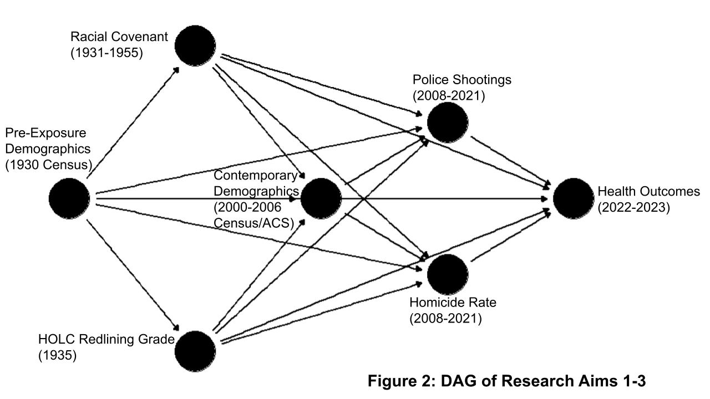

Power Analysis

Given that we have a maximum population of ZCTA units (n=50) that spatially intersect the city boundaries of Minneapolis and St. Paul, we performed a statistical power simulation to quantify the *minimum detectable effect* our study design can measure given our population size. This process involved iterating the following process over varying assumed effect sizes of each of Aims 1-3: 1) simulation of 100 datasets according to each Aim’s assumed data generating process, 2) performing the corresponding modeling strategy (as outlined in the Statistical Analysis section above) on each simulated dataset, 3) extracting the p-value corresponding to the focal coefficient, and 4) calculating the proportion of simulations that resulted in a p-value <.05 for each aim and assumed effect size. We then can then determine the minimum detectable effect size which reaches the conventional level of 80% power. With our population size we can reliably detect a minimum effect size of 0.19 for Aim 1 and 0.65 for Aim 2. Power simulations for the counterfactual mediation analysis are considerably more complex given the number of parameters of interest. For the counterfactual mediation analysis, we perform a power simulation leveraging hypothesized direct and indirect effect sizes from our previous scholarship,28,29 alongside a covariate and treatment-mediator confounding, resulting in power levels of 65% (CDE), 61% (PIE), and 64% (PAI) for each respective parameter. However, we do have a population of ZCTAs for Minneapolis and St. Paul, and given the concern of null hypothesis testing,31 we will focus on evaluating effect magnitudes as opposed to statistical significance thresholds.

*Qualitative Interview Design (Aim 4)*

First, we will incorporate community perspectives into our study design by conducting 3 focus group interviews with 18 residents of impacted ZCTAs within Minneapolis and St. Paul (i.e., 3 focus groups of six participants each), prioritizing residents in areas of historic redlining. We will use these focus groups to obtain residents’ feedback on proposed interview questions, identify additional areas of inquiry, and discuss potential policy solutions. We will work with local health organizations (i.e., community health clinics and hospitals) serving eligible ZCTAs to recruit focus group and study participants from their adult client population. We will also recruit prospective participants by mailing study invitations to eligible ZCTA addresses and screening responding individuals for eligibility.

We propose to conduct 40 semi-structured interviews to understand how police shootings affect health outcomes, and how strategies of resilience used by community members may shape these processes (Aim 4). Specifically, we will interview adult residents of Twin City-area ZTCAs that have experienced a recent (2015-present) police shooting. Interviews with residents of these ZTCA will allow our analysis to identify potential mechanisms, including police shooting-induced stress perceptions, coping behaviors, and resiliency, that link exposure to police shootings to residents’ health outcomes.

Each interview will last approximately 60 to 90 minutes and occur in-person. We will record each interview (using an audio recorder) with the participant’s permission. If a participant refuses to be recorded, the interviewer will take written notes that note key quotations, stories, and themes. The interviews will focus on a discussion of residents’ perceptions of their general health and health behaviors, well-being and stress, their attitudes and experiences with community and police gun violence, and their perceived stress and emotional and problem-solving coping strategies following a police shooting exposure. In order to address the traumatic nature of police violence exposure our team will attend Cornell’s Trauma Informed Care training.32 Participants will receive $60 compensation for their insights and time.

After each interview, the interviewer will draft an interview summary that includes the participant’s pseudonym, a summary of the interview’s findings, an identification of key themes, quotations, and points of confusion, a comparison to the findings of other interviews, and an evaluation of the interview logistics (e.g., how well did the interview location work?). We will use these interview summaries and extant research literature to guide the coding of each participant’s interview transcript.

We will first code for descriptive and identify basic conceptual categories. We will then draft analytical memos that highlight common themes and identify patterns across participants by demographics (e.g., class position, age, parental status). We will update and re-code the interviews as we encounter new insights from existing literature and participant interviews. Once coding is completed, we meet again as a team to discuss major themes and draft final analytical memos.

**Equity in the Research Process**

Our project is rooted in equity. We seek to understand the modern-day mechanism, police shootings, role in the historical processes of structural racism, and the (re)production of firearm injury and other contemporary health problems. Our research methodology to investigate the impact of historical structural racism on contemporary police violence and health outcomes is a mixed method design in Minneapolis and St. Paul, Minnesota. Each of the authors has been embedded in Minneapolis and St. Paul with deep connections to the community, conducting listening sessions as, e.g., board members and researchers for the Minnesota Justice Research Center, the University Urban Research and Outreach-Engagement Center, the Restore the Vote Coalition, the Liberal Arts Engagement Hub, and the Minneapolis Mayor’s Public Safety Task Force. These experiences, particularly the community listening sessions and our continuing engagement with community partners, has helped shape the proposed project. Our qualitative aim will enhance understanding of the impact of police violence on population health by identifying potential mechanisms, such as resiliency, that shape the health consequences of police shooting exposure.

The ultimate goal of our project is to center the voices of the traditionally marginalized and powerless. We adopt an asset-based, trauma-informed approach to minimize potential harm to participants and to highlight the existing strengths of traditionally marginalized communities. As a result, our project will make three equity-focused contributions. First, our study hopes to elucidate the mechanism by which health disparities occur in our society, and to better understand the historical roots of these inequities. Second, the interviews we conduct in communities where police shootings occurred will help inform future interventions that build upon existing resilience in minoritized communities. Third, the analytical framework we will establish will allow for additional examinations of different health conditions such as birth outcomes.

**Key Challenges and Solutions**

Below we discuss each challenge and then our solution:

First, our current quantitative design estimates the average effect of police shootings. Our measure of police shootings (yes/no or a rate) does not disentangle the heterogeneity of each police shooting event. For example, the murder of George Floyd likely had a markedly different aftermath than other police shooting events. In order to disentangle the heterogeneity of police shootings, we will cross reference police shootings with other police shooting databases (e.g., the Fatal Encounters Database33) that contains more information on the *qualities* of each individual incident. This will allow us to a) better ascertain the nature and characteristics of each police fatal shooting and b) investigate effect heterogeneity amongst different types of police shootings (e.g., officer-target race dyad, armed target, lethality, etc.).

Second, a key challenge to our quantitative design is the limited spatial resolution in hospital discharge data. We are restricted to the ZCTA area, and our focal structural racism exposures vary at more resolute spatial units (e.g., individual properties in terms of racial covenants). We overcome this challenge by operationalizing the proportion of each ZCTA in our sample that is subject to each treatment, allowing for a large amount of variation between ZCTAs in exposure to structural racism.

Third, we may struggle to recruit individuals and expect a high level of vulnerability in our focus groups/interviews. We believe that we will overcome this challenge in several ways. We are partnering with local organizations with established representation and trust in the communities. We will do our best for our interviewers to have racial identity concordance to help with an established level of understanding. Finally, our interviewers/team members will be taking a trauma informed interviewing course through the Center for Cultural Humility to better prepare for the interviews. Further, this training will also help us better support our interviewers and team given the possibility of secondary traumatic stress.

**Research Team**

Our interdisciplinary research team has worked together for 4 years. We are well-positioned for this research, having produced several manuscripts on police violence,28,29 firearm assault injury,28 and related phenomena.30

N. Jeanie Santaularia (MPI), is an Assistant Professor and a member of the Firearm Injury & Policy Research Program at the University of Washington School of Public Health. She is a trained social epidemiologist with substantive and methodological expertise in violence prevention.34,35 Her current research examines how social and institutional determinants cumulatively influence violence over the life course and the role of community, psychosocial and family protective factors in offsetting negative outcomes due to violence.36,37 Ryan Larson(MPI) is an Assistant Professor of Criminology at Hamline University. He is a sociologist and criminologist whose research broadly examines the social consequences of punishment and policing on crime, stratification, and other aspects of social life. He is a quantitative methodologist with expertise in panel modeling, spatial analysis, and causal inference.28,30 Christopher Uggen (Co-PI) is a sociologist and criminologist with longstanding interest in violence, health, and population dynamics, including his most recent book, *Prison and Health in the Age of Mass Incarceration* (2022, Oxford). He is a recent Vice President of the American Sociological Association and a fellow of the American Society of Criminology with expertise in multi-method research. Dr. Uggen is especially committed to conducting research with public impact, received the ASA 2023 Public Understanding of Sociology award, and has been an invited speaker at the White House. Christopher Robertson (Graduate Research Assistant) is a Ph.D. candidate in Sociology at the University of Minnesota and a Robert Wood Johnson Foundation Health Policy Research Scholar. His research examines how criminal justice contact, especially policing and probation, perpetuates population health and how individuals make sense of policing, police violence and community safety.38,39

**Research Ethics Considerations**

We will obtain Institutional Review Board approval from the Human Subjects Division of the University Minnesota, University of Washington and Hamline University.

**Plans for Dissemination**

Given the strength of this interdisciplinary team, we will prepare several peer reviewed papers at high impact factor (American Journal of Epidemiology and American Journal of Sociology); several public-facing research briefs, and several press releases. In addition, all of our manuscripts, reports, analytic code, and data (when ethically allowable) will be made publicly available for an added layer of transparency and accountability. We will present our findings at national academic meetings, such as the American Society of Criminology, Society for Epidemiologic Research, and Society for Advancement of Violence and Injury Research. In addition, we will present research at the Minnesota Social Service Associations meeting. It is the largest health and human service conference in the Midwest, reaching 3,000 health and human service professionals. Finally, we will promote our findings using our own academic social media accounts as well as our Universities’ websites.

**Timeline**

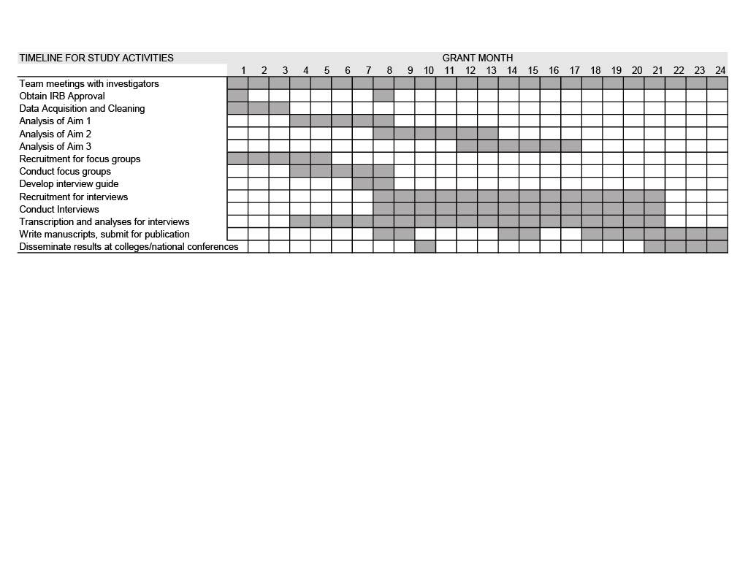

**Bibliography**

1. Mapping Police Violence. Accessed August 19, 2021. https://mappingpoliceviolence.org/

2. Lyons CJ, Painter-Davis N, Medaris DC. The Lynching Era and Contemporary Lethal Police Shootings in the South. *Race and Justice*. Published online August 15, 2022:21533687221120950. doi:10.1177/21533687221120951

3. Ross CT. A Multi-Level Bayesian Analysis of Racial Bias in Police Shootings at the County-Level in the United States, 2011–2014. *PLOS ONE*. 2015;10(11):e0141854. doi:10.1371/journal.pone.0141854

4. Geller A, Fagan J, Tyler T, Link BG. Aggressive Policing and the Mental Health of Young Urban Men. *Am J Public Health*. 2014;104(12):2321-2327. doi:10.2105/AJPH.2014.302046

5. Alang S, McAlpine D, McClain M. Police Encounters as Stressors: Associations with Depression and Anxiety across Race. *Socius*. 2021;7:1-13. doi:https://doi.org/10.1177/2378023121998128

6. Salas-Hernández L, DeVylder JE, Cooper HLF, et al. Latent Class Profiles of Police Violence Exposure in 4 US Cities and Their Associations with Anticipation of Police Violence and Mental Health Outcomes. *J Urban Health*. 2022;99(4):655-668. doi:10.1007/s11524-022-00643-5

7. DeVylder JE, Anglin DM, Bowleg L, Fedina L, Link BG. Police Violence and Public Health. *Annu Rev Clin Psychol*. 2022;18:527-552. doi:10.1146/annurev-clinpsy-072720-020644

8. Haile R, Rowell-Cunsolo T, Hyacinthe MF, Alang S. “We (still) charge genocide”: A systematic review and synthesis of the direct and indirect health consequences of police violence in the United States. *Social Science & Medicine*. 2023;322:115784. doi:10.1016/j.socscimed.2023.115784

9. Hicken MT, Miles L, Haile S, Esposito M. Linking History to Contemporary State-Sanctioned Slow Violence through Cultural and Structural Racism. *The ANNALS of the American Academy of Political and Social Science*. 2021;694(1):48-58. doi:10.1177/00027162211005690

10.Faber J. Contemporary echoes of segregationist policy: Spatial marking and the persistence of inequality. *Urban Studies*. 2021;58(5):1067-1086. doi:10.1177/0042098020947341

11.Graetz N, Esposito M. Historical Redlining and Contemporary Racial Disparities in Neighborhood Life Expectancy. *Social Forces*. Published online October 31, 2022:soac114. doi:10.1093/sf/soac114

12.Alang S, VanHook C, Judson J, Ikiroma A, Adkins-Jackson PB. Police brutality, heightened vigilance, and the mental health of Black adults. *Psychology of Violence*. 2022;12(4):211-220. doi:10.1037/vio0000418

13.Mitchell J, Chihaya GK. Tract level associations between historical residential redlining and contemporary fatal encounters with police. *Social Science & Medicine*. 2022;302:114989. doi:10.1016/j.socscimed.2022.114989

14.Smith Lee JR, Robinson MA. “That’s My Number One Fear in Life. It’s the Police”: Examining Young Black Men’s Exposures to Trauma and Loss Resulting From Police Violence and Police Killings. *Journal of Black Psychology*. 2019;45(3):143-184. doi:10.1177/0095798419865152

15.Burt CH, Simons RL, Gibbons FX. Racial Discrimination, Ethnic-Racial Socialization, and Crime: A Micro-sociological Model of Risk and Resilience. *Am Sociol Rev*. 2012;77(4):648-677. doi:10.1177/0003122412448648

16.Located Institutions: Neighborhood Frames, Residential Preferences, and the Case of Policing. doi:10.1086/708004

17.Ward G. Living Histories of White Supremacist Policing: Towards Transformative Justice. *Du Bois Rev*. 2018;15(1):167-184. doi:10.1017/S1742058X18000139

18.United States Department of Justice Civil Rights Division, United States Attorney’s Office District of Minnesota Civil Division. *Investigation of the City of Minneapolis and the Minneapolis Police Department*.; 2023:1-89. https://www.justice.gov/d9/press-releases/attachments/2023/06/16/minneapolis_findings_report_2023.06.15_0.pdf

19.Minnesota Hospital Association. Accessed June 2, 2023. https://www.mnhospitals.org/

20.Open Minneapolis. Accessed June 2, 2023. https://opendata.minneapolismn.gov/

21.St Paul Open Information. Accessed June 2, 2023. https://information.stpaul.gov/

22.US Census Bureau. Decennial Census by Decades. The United States Census Bureau. Accessed September 6, 2021. https://www.census.gov/programs-surveys/decennial-census/decade.html

23.US Census Bureau. American Community Survey (ACS). Census.gov. Published 2010. Accessed January 29, 2022. https://www.census.gov/programs-surveys/acs

24.Mapping Prejudice. Accessed June 2, 2023. https://mappingprejudice.umn.edu/

25.Graded Neighborhoods by Home Owners’ Loan Corporation : Minnesota Natural Resource Atlas. Accessed June 2, 2023. https://mnatlas.org/resources/graded-neighborhoods-by-home-owners-loan-corporation/

26.Hill AB. Before Redlining and Beyond. *Metropolitics*. Published online November 2, 2021. Accessed June 2, 2023. https://metropolitics.org/Before-Redlining-and-Beyond.html

27.Graetz N, Boen CE, Esposito MH. Structural Racism and Quantitative Causal Inference: A Life Course Mediation Framework for Decomposing Racial Health Disparities. *J Health Soc Behav*. 2022;63(2):232-249. doi:10.1177/00221465211066108

28.Larson R, Santaularia NJ, Uggen C. Temporal and Spatial Shifts in Gun Violence, Before and After a Historic Police Killing in Minneapolis. *Spatial and Spatio-temporal Epidemiology*.

29.Santaularia NJ, Larson R, Robertson C, Uggen C. The Mental Health Consequences Before and After George Floyd’s Murder in Minneapolis in Black, Latine, and White Communities. *American Journal of Epidemiology*.

30.Santaularia NJ, Larson R, Uggen C. Criminal punishment and violent injury in Minnesota. *Inj Epidemiol*. 2021;8:11. doi:10.1186/s40621-021-00303-3

31.Lash TL. The Harm Done to Reproducibility by the Culture of Null Hypothesis Significance Testing. *American Journal of Epidemiology*. 2017;186(6):627-635. doi:10.1093/aje/kwx261

32.Trauma-Informed Care Training. Center for Cultural Humility. Published January 27, 2023. Accessed August 4, 2023. https://humility.cornell.edu/trauma-informed-care-training/

33.Fatal Encounters – A step toward creating an impartial, comprehensive and searchable national database of people killed during interactions with police. Accessed August 4, 2023. https://fatalencounters.org/

34.Santaularia NJ, Ramirez MR, Osypuk TL, Mason SM. Economic Hardship and Violence: a comparison of economic measures in the prediction of county-level rates of violence-related injury. Published online 2021.

35.Santaularia NJ, Osypuk TL, Ramirez MR, Mason SM. Violence in the Great Recession. *Am J Epidemiol*. 2022;191(11):1847-1855. doi:10.1093/aje/kwac114

36.Santaularia NJ, Ramirez MR, Osypuk TL, Mason SM. Measuring the Hidden Burden of Violence: Use of explicit and proxy diagnosis codes for violence in Minnesota Injury Hospitalizations, 2004-2014. Published online 2021.

37.Friedman JK, Santaularia NJ, Dadi D, Erickson DJ, Lust K, Mason SM. The influence of childhood and early adult adversities on substance use behaviours in racial/ethnically diverse young adult women: a latent class analysis. *null*. Published online September 28, 2021:1-12. doi:10.1080/17457300.2021.1982990

38.Phelps MS, Osman IH, Robertson CE, Shlafer RJ. Beyond “pains” and “gains”: untangling the health consequences of probation. *Health Justice*. 2022;10(1):29. doi:10.1186/s40352-022-00193-7

39.Phelps MS, Robertson CE, Powell AJ. “We’re Still Dying Quicker Than We Can Effect Change”: #BlackLivesMatter and the Limits of 21st-Century Policing Reform. *American Journal of Sociology*. 2021;127(3):867-903. doi:10.1086/717671